|  |  |
| --- | --- |
| Picture 2 | «File Converter» Project |
| Requirements  Project Documentation |
|  |  |
| Background | Full set of requirements specification. |
| Purpose | To organize both development and testing process. |
| Scope | Business requirements, user requirements, detailed specification, limitations. |
| Audience | Management staff, project team. |
| File | 03 06 - Requirements Sample.docx |
|  | |

Contents

1. Project scope 3
2. Main goals 3
3. Criteria for main goals achievement 3
4. Risks 3
5. System characteristics 3
6. User requirements 3
7. Business rules 4
8. Quality attributes 4
9. Limitations 5
10. Detailed specifications 5
11. Project scope

Development of a tool to eliminate encoding multiplicity in text documents stored locally.

1. Main goals

* Eliminate the necessity for manual detection and conversion of encoding in text documents.
* Decrease document-processing time by the amount needed for manual encoding detection and conversion.

1. Criteria for main goals achievement

* Full automation of encoding detection and conversion.
* Document-processing time reduction by 1-2 minutes (average) due to elimination the necessity for manual encoding detection and conversion.

1. Risks

* High complexity of accurate detection of text document initial encoding.

1. System characteristics

* SC-1: The application should be a console one.
* SC-2: The application should be developed using PHP (see L-1 for the explanation; PHP-related details are described in DS-1).
* SC-3: The application should be a multi-platform one (taking into account L-4).

1. User requirements

* See also the use cases diagram below for details.
* UR-1: Start and stop of the application.
  + UR-1.1: The application start should be performed by the following console command: “php converter.phar SOURCE_DIR DESTINATION_DIR [LOG_FILE_NAME]” (see DS-2.1 for parameters description, see DS-2.2, DS-2.3, and DS-2.4 for error messages on any misconfiguration situation).
  + UR-1.2: The application stop (shutdown) should be performed by applying Ctrl+C to the console window, which holds the running application.
* UR-2: Configuration of the application.
  + UR-2.1: The only configuration available is through command line parameters (see DS-2).
  + UR-2.2: Target encoding for text file conversion is UTF8 (see also L-5).
* UR-3: Application log.
  + UR-3.1: The application should output its log both to the console and to a log-file (see DS-4). Log file name should comply with the rules described in DS-2.1.
  + UR-3.2: Log contents and format are described in DS-4.1, the application reaction to log file presence/absence is described in DS-4.2 and DS-4.3 accordingly.

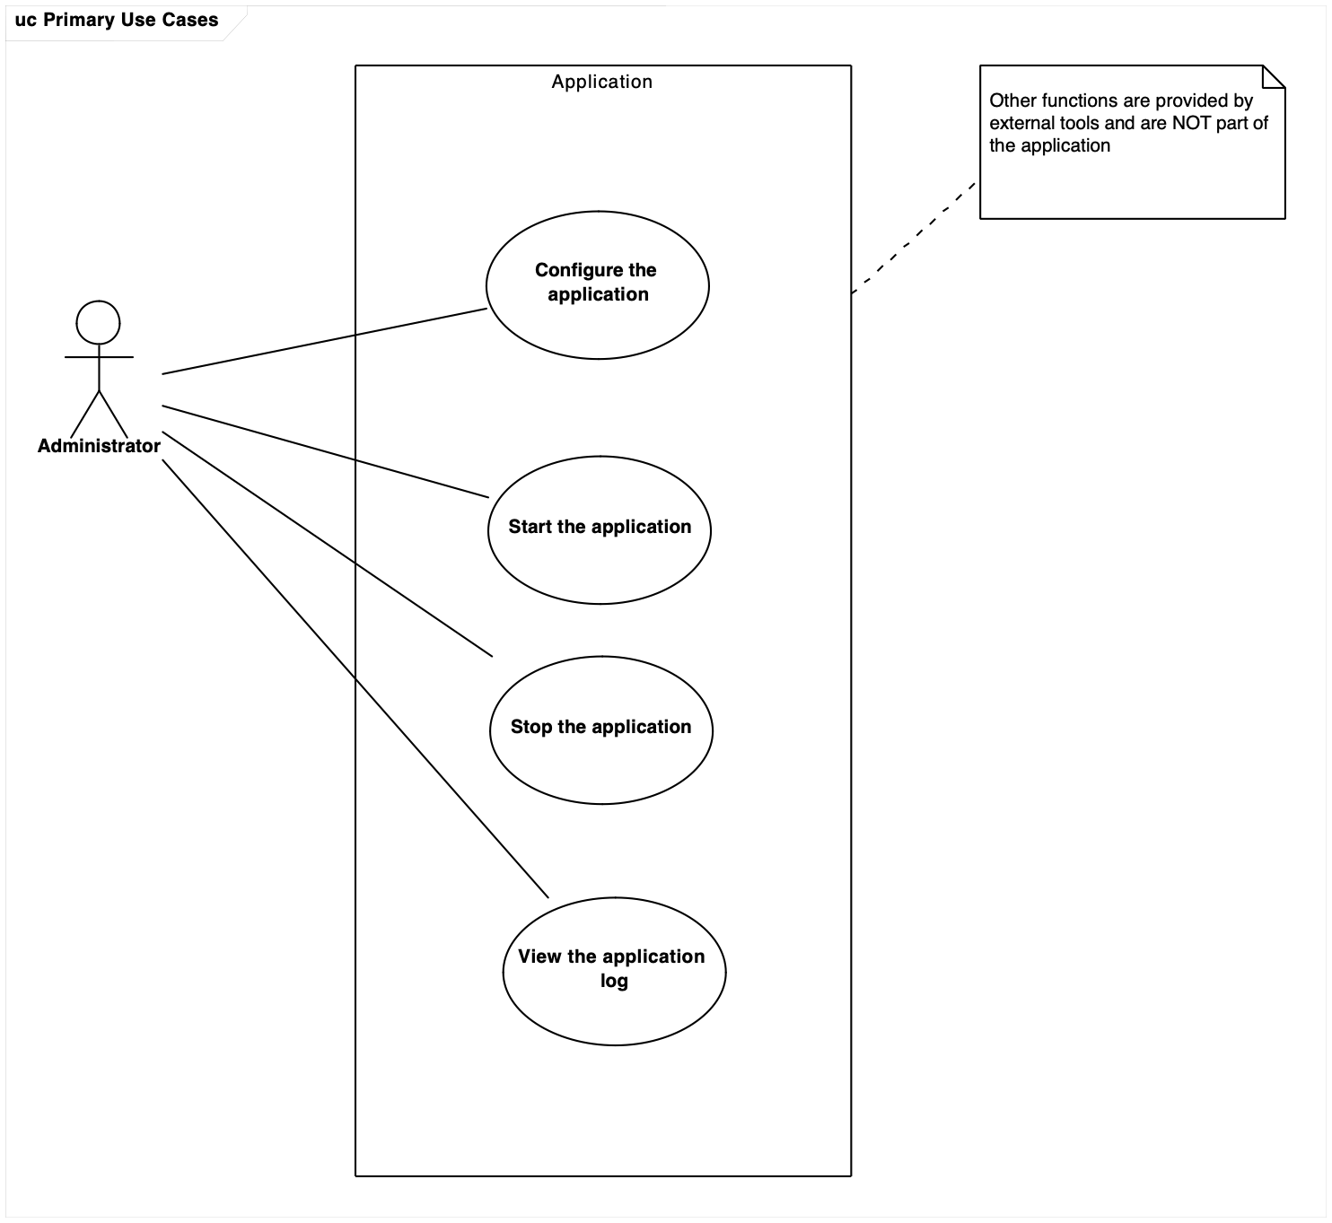

1. Business rules

* BR-1: The source directory and the destination directory
  + BR-1.1: The source directory and the destination directory may NOT be the same directory (see also DS-2.1 and DS-3.2).
  + BR-1.2: The destination directory may NOT by inside the source directory or any its subdirectories (see also DS-2.1 and DS-3.2).

1. Quality attributes

* QA-1: Performance
  + QA-1.1: The application should provide the processing speed of at least 5 MB/sec with the following (or equivalent) hardware: CPU i7, RAM 4 GB, average disc read/write speed 30 MB/sec. See also L-6.
* QA-2: Resilience to input data
  + QA-2.1: See DS-5.1 for the requirements to input file formats.
  + QA-2.2: See DS-5.2 for the requirements to input file size.
  + QA-2.3: See DS-5.3 for the details on application reaction on incorrect input file format.

1. Limitations

* L-1: The application should be developed using PHP as the Customer is going to support the application with his own IT-department.
* L-2: See DS-1 for PHP version and configuration details.
* L-3: PHP setup and configuration process are out of this project scope and therefore are NOT described in any product/project documentation.
* L-4: Multi-platform capabilities of the application are the next: it should work with Windows and Linux assuming that proper PHP version (see DS-1.1) works there.
* L-5: The target encoding (UTF8) is fixed. There is no option to change it.
* L-6: The QA-1.1 may be violated in case of objective reasons (e.g., system overload, low-performing hardware and so on).

1. Detailed specifications

**DS-1: PHP**

DS-1.1: Minimal version – 5.5.

DS-1.2: The mbstring extension should be installed and enabled.

**DS-2: Command line parameters**

DS-2.1: The application receives three command line parameters during the start process:

* SOURCE_DIR – mandatory parameter, points to the directory with files to be processed;
* DESTINATION_DIR – mandatory parameter, points to the directory to store converted files (see also BR-1.1 and BR-1.2);
* LOG_FILE_NAME – optional parameter, points to the log file (if omitted, “converter.log” file should be created in the same directory where “converter.phar” is located);

DS-2.2: If some mandatory command line parameter is omitted, the application should shut down displaying standard usage-message (see DS-3.1).

DS-2.3: If more than three command line parameters are passed to the application, it should ignore any parameter except listed in DS-2.1.

DS-2.4: If the value of any command line parameter is incorrect, the application should shut down displaying standard usage-message (see DS-3.1) and incorrect parameter name, value, and proper error message (see DS-3.2).

**DS-3: Messages**

DS-3.1: Usage message: “USAGE converter.phar SOURCE_DIR DESTINATION_DIR LOG_FILE_NAME”.

DS-3.2: Error messages:

* Directory not exists or inaccessible.
* Destination dir may not reside within source dir tree.
* Wrong file name or inaccessible path.

**DS-4: log**

DS-4.1: The log format is the same for the console and the log file: YYYY-MM-DD HH:II:SS operation_name operation_parameters operation_result.

DS-4.2: If the log-file is missing, a new empty one should be created

DS-4.3: If the log file exists, the application should append new records to its tail.

**DS-5: File format and size**

DS-5.1: The application should process input files in Russian and English languages with the following encodings: WIN1251, CP866, and KOI8R.

Supported file formats (defined by extension) are:

* Plain Text (TXT).
* Hyper Text Markup Language Document (HTML).
* Mark Down Document (MD).

DS-5.2: The application should process files up to 50 MB (inclusive), the application should ignore any file with the size larger than 50 MB.

DS-5.3: If a file with supported format (see DS-5.1) contains format-incompatible data, such data may be damaged during file processing, and this situation should be treated as correct application work.